Version 1.2.0



Group 12

ibm Skillsbuild

User manual

Contents

1. **Getting Started**
   1. 1.1 Creating an Account
   2. 1.2 Navigating the Dashboard
   3. 1.3 Using the Dashboard to submit a review
2. **Earning Points and Rewards**
   1. 2.1 Completing Courses
   2. 2.2 Daily Spin Wheel
   3. 2.2 Levelling Up
3. **Leaderboards and Competition**
   1. 3.1 How the Leaderboard Works
4. **Your User Profile**
   1. 4.1 Viewing Progress
   2. 4.2 Customizing Settings
5. **Time Trials** 
   1. 5.1 How the Time-Trials work
   2. 5.2 Taking a Time-Trial
   3. 5.3 The Trial leaderboard
   4. 5.4 Reviewing Previous Attempts
6. **Marketplace**
   1. 6.1 What is the Market?
   2. 6.2 How to View Items
   3. 6.3 Placing Orders
      1. 6.3.1 Buying
      2. 6.3.2 Selling
7. **Frequently Asked Questions (FAQs)**
   1. 7.1 General FAQs
   2. 7.2 Account and Login FAQs
   3. 7.3 Course FAQs
   4. 7.4 Points, Rewards, and Levels FAQs
   5. 7.5 Leaderboards FAQs
   6. 7.6 Technical FAQs

**Section 1: Getting Started**

1.1 Creating an Account

To create an account with CourseXP, simply navigate to the home page at:

http:localhost:8080/

From here, there are two ways to navigate to the registration page. Either navigate to it via the ***‘Get Started’*** button, or via the ***‘Register’*** button in the navigation bar at the top of the screen. Both options are highlighted below:

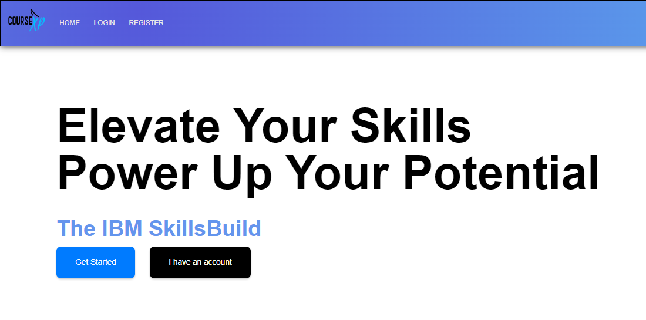

You will be greeted with a page like the one below:

From here enter your credentials to your new account, and once complete, click the ***‘Register’*** button at the bottom of the page. If you have navigated to this page in error, simply click the ***‘Sign In'*** button at the very bottom of the page. Our logo ***‘CourseXP’*** is also clickable and will redirect you to the home page.

**Congratulations, if you have followed the instructions above, you have just registered an account with us!**

*To log in, simply navigate to the login page, links for which have been outlined in the instructions above.*

1.2 Navigating the Dashboard

*Prerequisites to this section involve having registered an account with us and having logged in with those credentials.*

You’re ready to navigate our app. After logging in, you should have been greeted with your dashboard page, showing all courses you can take.

When you start a course, you’ll see them on this page too. Below is a general outline of what you can currently see:

Button to open this menu

Logout button

All available courses to you

Link to this page

The button to start the course

Link to the leaderboard *(see section 3.1)*



After starting a course, you’ll see a menu open below the available courses appear, as shown below. This menu will allow you to pick up where you left off with your courses, so you don’t have to complete them all in one go. It will also allow you to mark a course as completed, adding that course to your list of completed courses, and adding your earned points for that course to the global leaderboard *(see section 3.1)*

1.3 Using the dashboard to submit a review

After a user has finished a course, they are able to click on the ‘Finish’ button *(see 1.2)*. After clicking on this, the screen should look like this:

This modal prompts the user to give the course a rating between 1-5, using the arrows in the first box and a written review in the second box.

Once the user clicks on the submit feedback button in black, the review will be stored into our database provided it satisfies the conditions of our error handling – cannot be empty.

**Section 2: Earning Points and Rewards**

2.1 Completing Courses

Upon completion of a course, you’ll be given points, alongside any badges you may have picked up along the way (you can view these in your profile). Points contribute towards your global leaderboard position.

A course that takes more time, or more skill to complete, will result in a higher point reward for completing it. Points earned can be boosted by our ***Daily Rewards*** system if the effect is active when the course is ended.

2.2 Daily Spin Wheel

Daily rewards, as the name suggests, are rewards that can be randomly won daily. The effects of the reward apply to all courses completed in that timeframe. Multipliers for points are won randomly on the Daily Reward Spin Wheel, ranging from 1.5x, 2x, and 3x, as shown below:

Each day, you will be prompted to spin the wheel, and win whatever multiplier the wheel lands on. It will then effect the points you earn for completing the course, which is shown by the levelling bar under the header *(see section 2.3).*

2.3 Levelling Up

This system visually represents the progress you have made by completing courses. Every time you complete a course, the progress bar will fill up accordingly, and will multiply by the amount you achieved by spinning the wheel for that day. Once the bar fills up, you will receive a pop up that you have levelled up to the next level. Not only that, but for you to keep track of your level, not only the progress, next to the bar is the current level that you are on, as shown below:

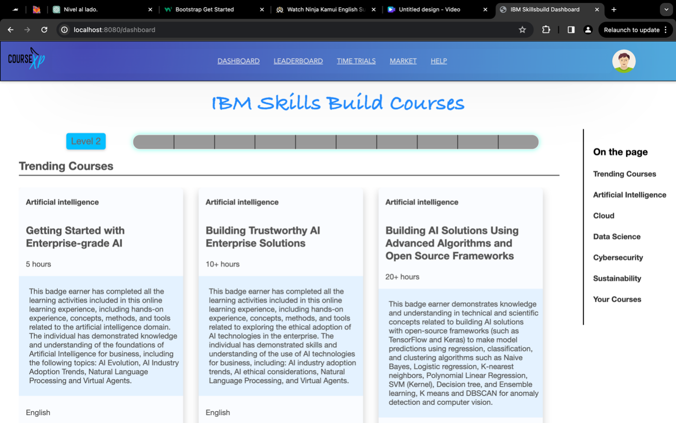

Your current level

Progress bar that fills up as you complete courses

**Section 3: Leaderboards and Competitions**

3.1 How the Leaderboard Works

The Global Leaderboard is a collective of everybody competing to have the highest level of attainment. If somebody is higher on the leaderboard, they are either completing more courses, or are completing more complex courses.

It can be navigated to, either by typing in the URL:

http:localhost:8080/leaderboard

To create an account with CourseXP, simply navigate to the home page at:

Or simply by clicking the helpful link in the navigation bar at the top of the page:  


There are rewards for the highest level of players on the leaderboard, such as unique badges, and other mystery prizes.

Once a player starts a course, they automatically start competing on the Global Leaderboard, and the only way is up.

**Section 4: Your User Profile**

**4.1: Social**

The profile allows you to see your details and customise your bio for your other friends. Your profile will show a list of potential friends that can be added. Once you add someone, they will have a friend request appear on their profile, which they can accept once you have received a friend request. All friends you have will appear in your friend list; once there, you can go onto their profile and look at their bio and information about their courses. There is also a friend leaderboard, where all your friends will be on the leaderboard, and you can see how you place against your friends.

Potential friends once requested will appear on the other persons friend request.

Remove friend

Friend with hyperlink to their bio

Friend leaderboard

**4.2: Badges**

Badges keep track of non-leaderboard progress, like how many time trials you beat or how many friends you make. Each user has their badge progress unique to them.

The symbols group each badge by theme. There are some outliers, like the stylish badge, this is given to the user when their profile is updated.

**Section 5: Time Trials**

**5.1: How The Time-Trials work:**

Time Trials are weekly 15-question quizzes that users can take and compete against each other for top places on the trial’s leaderboard.

After creating an account/logging in (see section 1.1), you can access the trials page through the following link:

http:localhost:8080/trials

Or by simply clicking on the ‘Time Trials’ on the navigation bar:



You should be able to see the week’s trial on top, with a link to start it, number of participants, number of the attempts you have (usually 2), and a link to the trial’s leaderboard (in case there’s at least one participant). With old ones underneath it

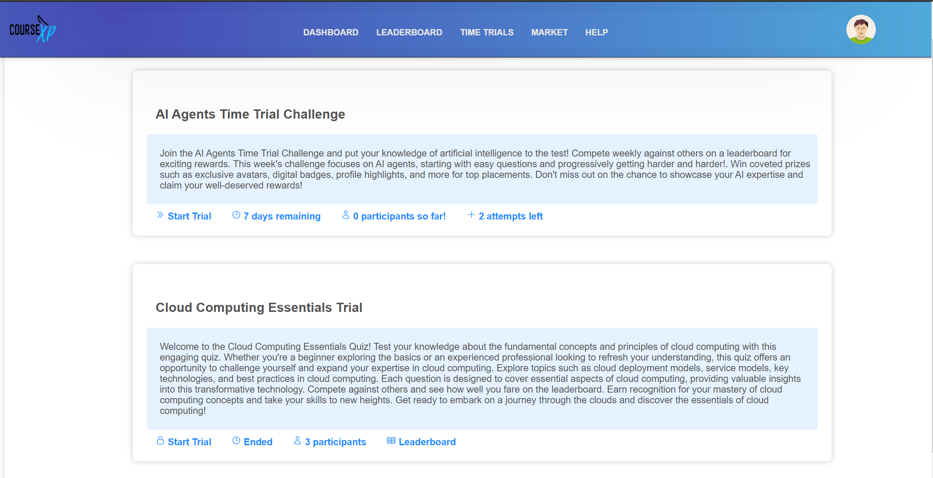

Lock to show trial can’t be started

Active trial

Start the trial

Old trial

Indicate the remining days for the time trial

Attempts remaining for the user

Number of users that did the trial

Current Page

**5.2: Taking a Time-Trial:**

After clicking on the start trial link (see 5.1) you should be redirected to the trial questions (if you have some attempts left). On the trial page you should see each question with choices (4 choices) and the points the question carries. To get points from the trial(I.e. your trial is saved) you should answer all 15-questions and hit the submit button at the end of the trial.

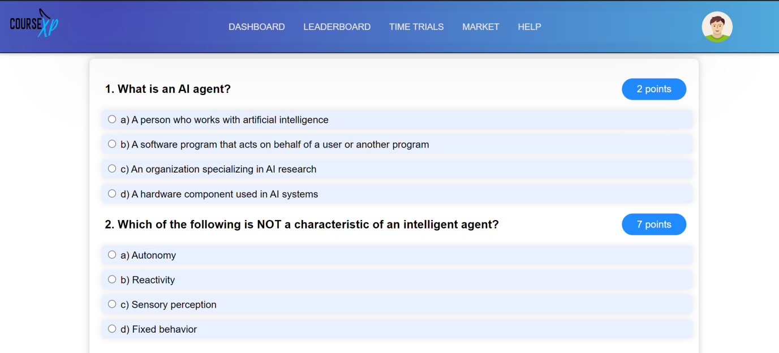

A question and its choices and points.

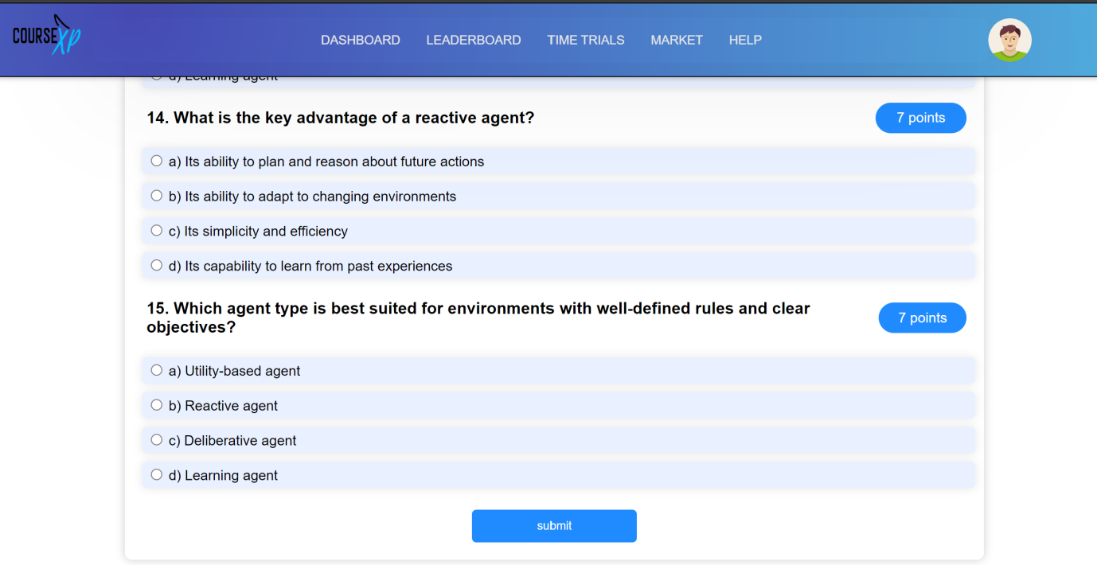

A Submit button to save the user’s response

**5.3: The Trial leaderboard:**

The Trial Leaderboard is a collective of users that took the trial competing to have the highest level of attainment.

The trial leaderboard link will be visible to users. there’s at least one user that took the trial.

After Taking the trial (see section 5.2), you will be able to see the link to the leaderboard in the trial card, if you click on it you will see your rank, name, and total score highlighted to make it easy for you to find your rank among other users.

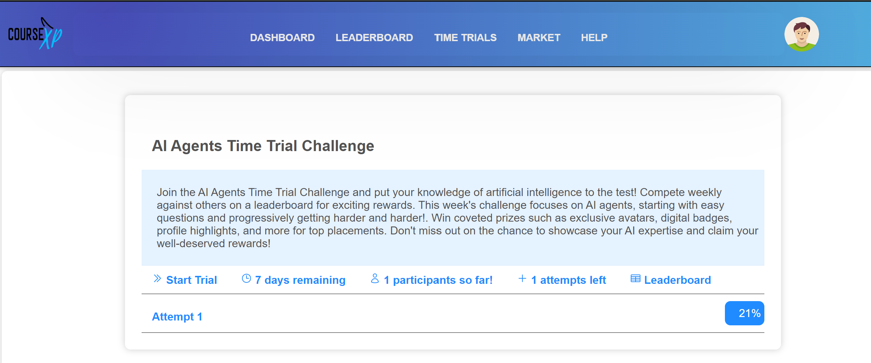

Link to the trial leaderboard

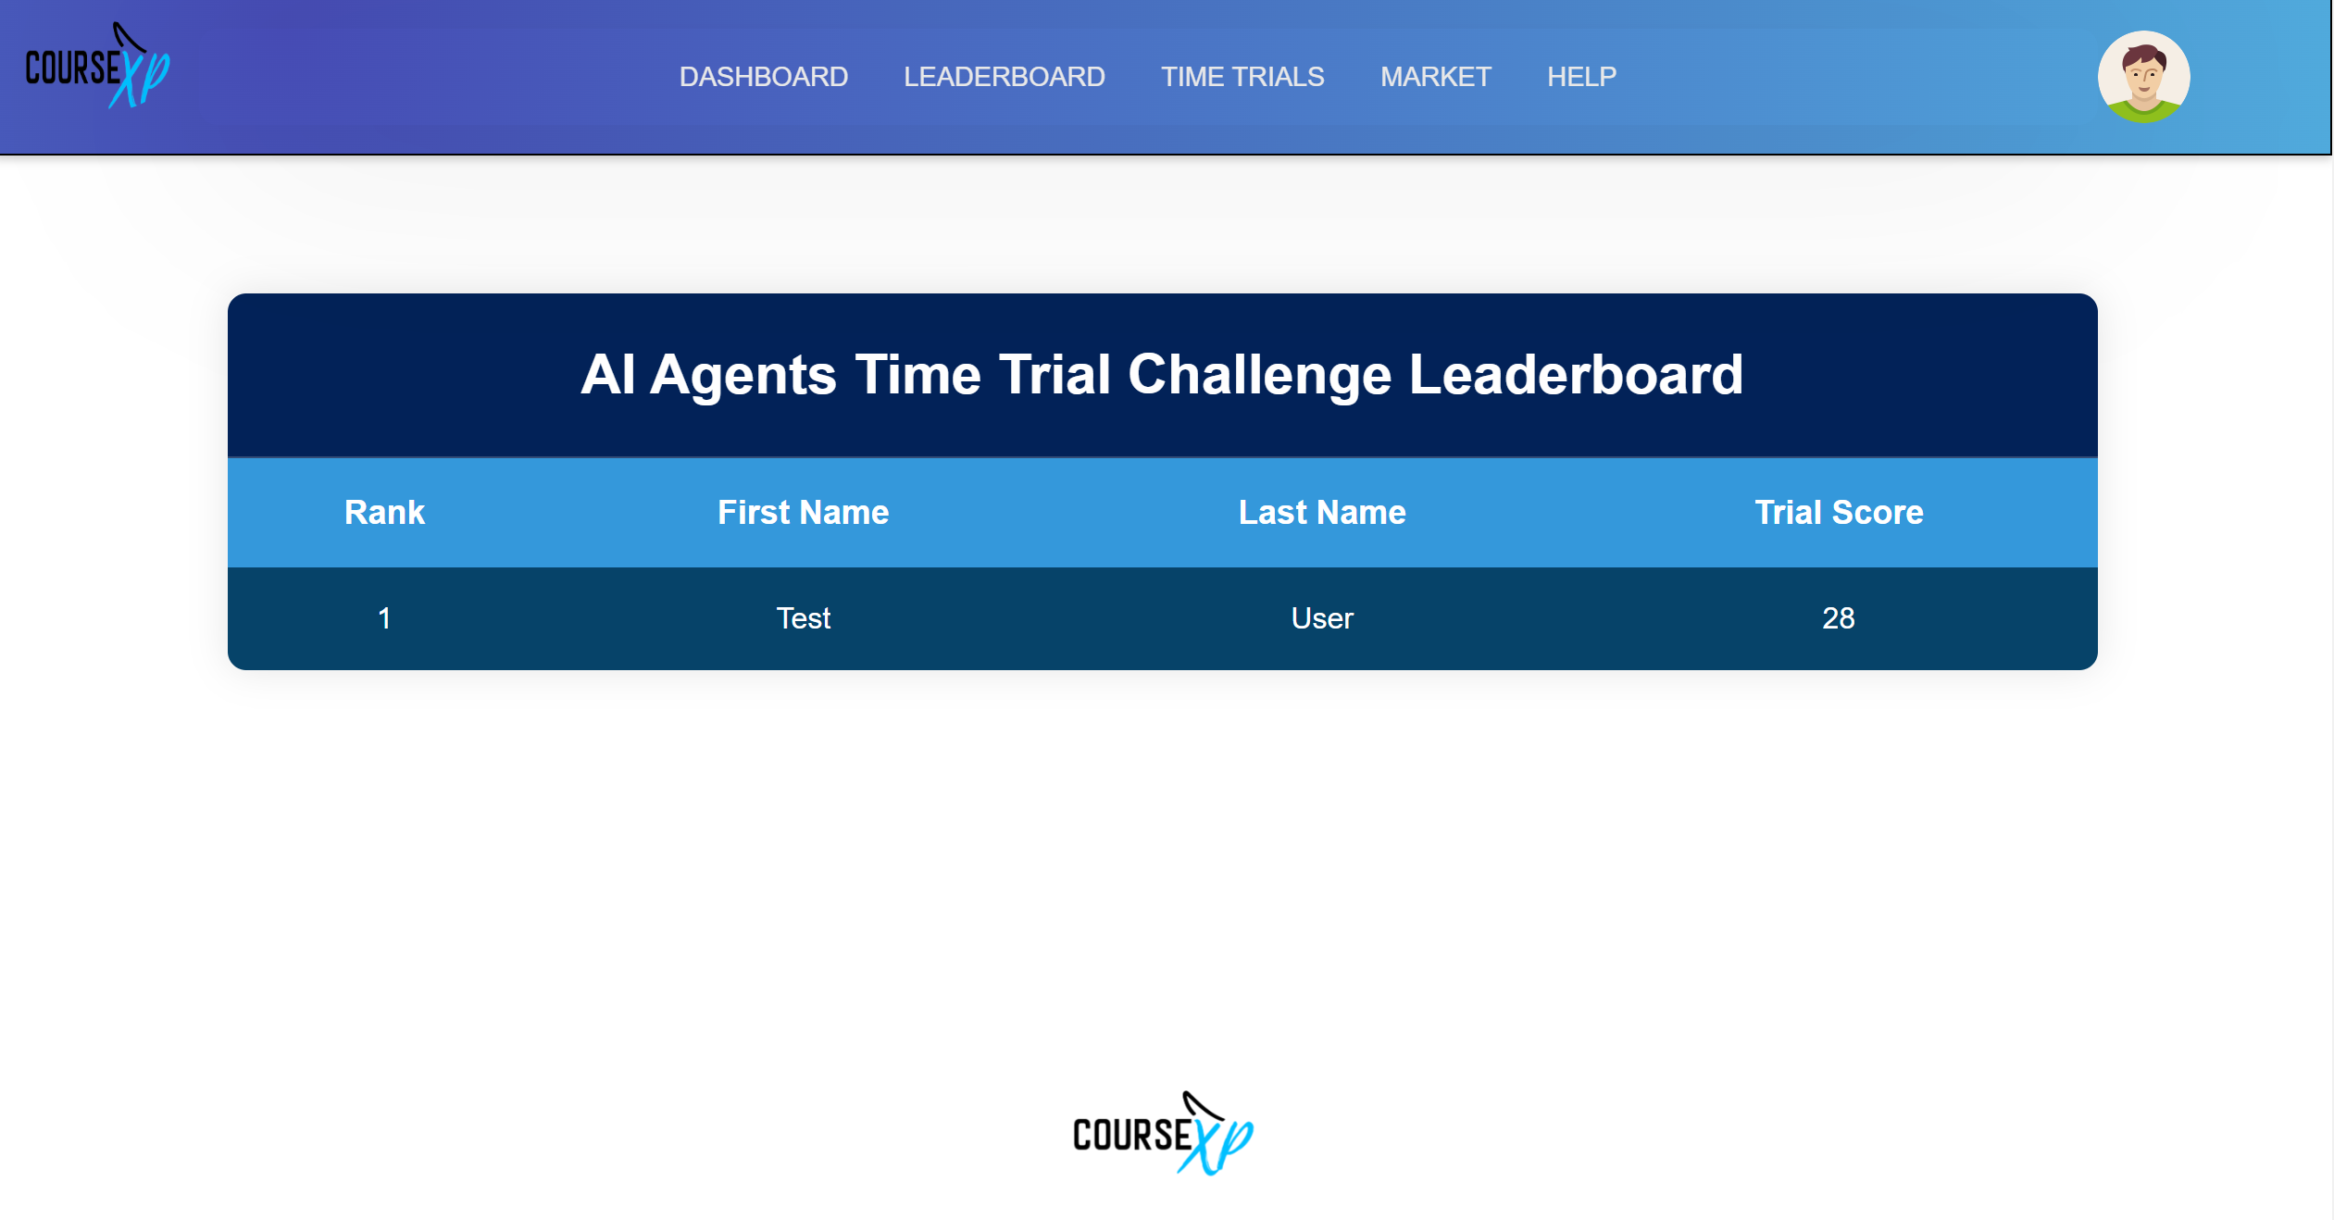

Trial name

Current user highlighted

**5.4: Reviewing previous attempts:**

After Taking the trial (see section 5.2), you should see a link to feedback (‘Attempt 1’ in the picture below) and a mark for your previous attempt (the ‘21%’. to the far right in the picture below)



Mark from attempt

Link to feedback

To access the feedback, you can click on the attempt link. After clicking on the link you should see the all the questions, each with your mark for the question next to it, and the answer annotated with the text ‘correct answer’. After you are done with the feedback you close the page by clicking on the button close, or by using the navigation bar to choose your next page.

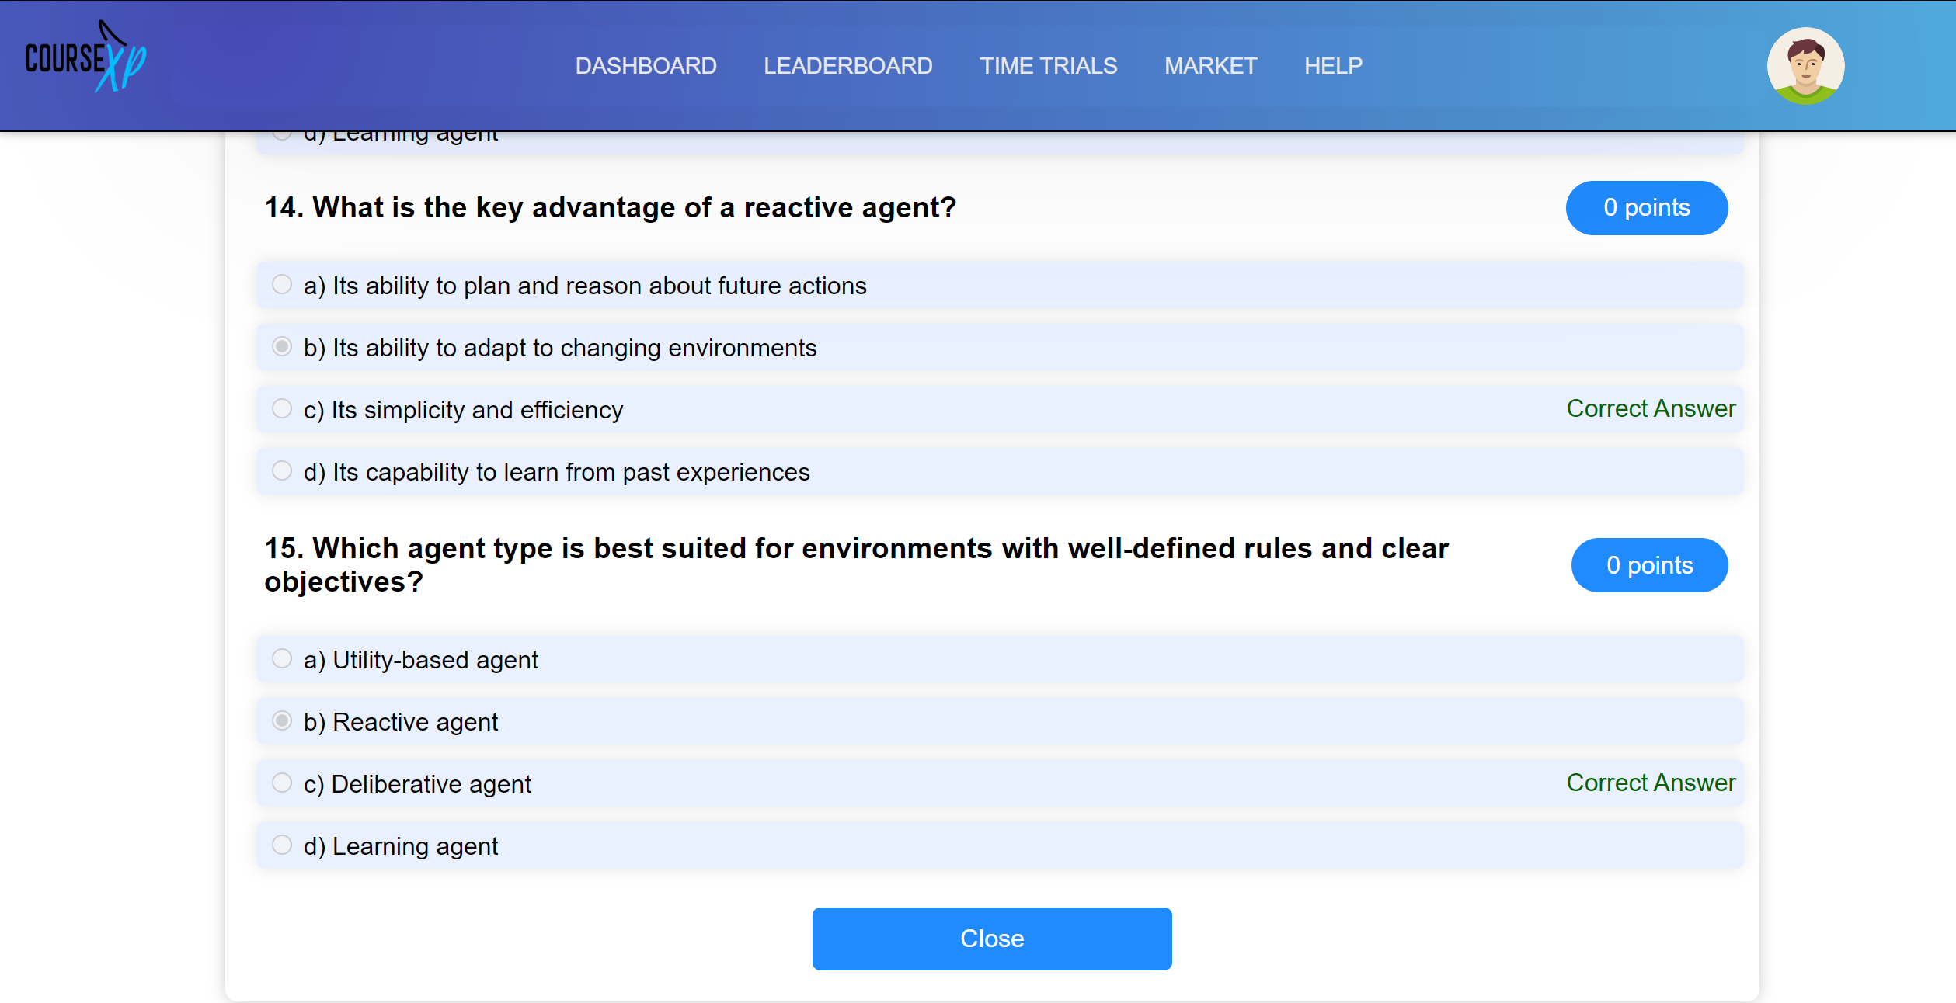

To close the feedback and go back to the trials page

Correct answer for the question

Points/marks for the question

**Section 6: Marketplace**

**6.1 What is the Market?**

The market is a place for everyone in CourseXP to trade their hard-earned items for cash and for buyers who want to customise their profile, level up faster, or buy other wide ranges of items for their user experience. When loading the market, you’ll be greeted with this page:

Pagination for looking through the whole table

Filter the table by Item Name or Category

This is the hub of all trades, showing all available categories of items to purchase and their associated minimum prices that others have listed on the market. You can search by item name or category, or if you want to browse, there’s a pagination section underneath the table where you can see all the available items to buy.

**6.2 How to View Items**

You can view items by clicking on them in the market listings. However, you ***cannot*** view items not available on the market unless they are in your inventory. At this point, you will view them in your inventory.

The individual item listings look like this (in this example, I have clicked on a 1 day access pass):

Individual listings that other members are selling.

View either specific item info, or all the associated listings of that item

Here, one can see all the detailed listings, their prices, and an image of the item the buyer wants. You can navigate to the **Item Info** tab if you want more information on the product you want to buy and buying or selling the item.

**6.3 Buying and Selling**

To buy and sell in the application, as mentioned before, navigate to the **Item Info** tab, where you will see this page:

Here you can see information on the market stance of the items.

The buy tab shows the minimum price you’ll have to pay to acquire the item now. However, you can enter a lower amount. If someone puts the item on the market for that price or lower, you’ll receive the item if your buy order was the first of that price placed. It runs on a first-come, first-served basis.

**6.3.1 Buying**

To place a buy order, you will see this pop-up window, where you’ll be asked to enter the quantity you wish to buy the item for, and how many of that item you wish to buy. Buy requests can be partially or wholly fulfilled depending on how many are available at that price. The buy order will be completed over time if the asking price is reasonable.

**6.3.2 Selling**

When selling an item, there is more leniency as to where how you sell, as any sell button on any page will allow full access to your inventory from a dropdown list. From there, you can see your items and the quantity you have of them. You can enter your desired asking price and how many you want to sell. Finally, after submitting that order, I will upload it to the market. ***It should be noted that the new listing will override if you submit a new sell order for the same item, regardless of whether you have leftover quantities in your inventory – before the previous listing sells.*A screenshot of a computer
**

**Section 7: Frequently Asked Questions**

**7.1 General FAQs**

**What is the purpose of this app?**

**How does the gamification aspect work?**

**Is there a cost to use the app?**

**Do I need an IBM SkillsBuild account to use this?**

**What devices and browsers are compatible with the app?**

**7.2 Account and Login FAQs**

**How do I create an account?**

**Can I use my university email to register?**

**I forgot my password. How do I reset it?**

**Can I link my existing IBM SkillsBuild account?**

**How do I update my profile information?**

**7.3 Course FAQs**

**How do I find and enrol in IBM SkillsBuild courses?**

**How do I start a challenge?**

**What's the difference between a course and a challenge?**

**Can I track my progress on courses?**

**Are there deadlines for completing courses or challenges?**

**7.4 Points, Rewards, and Levels FAQs**

**How do I earn points?**

**What kinds of rewards are available?**

**How does the levelling system work?**

**Where can I see my current points and level?**

**Do points or rewards expire?**

**7.5 Leaderboards FAQs**

**How do I view the leaderboards?**

**Are there different leaderboard categories?**

**How often are leaderboards updated?**

**Can I compete with just my friends or classmates?**

**7.6 Technical FAQs**

**A course isn't loading. What should I do?**

**My points aren't updating correctly. How do I fix this?**

**Who do I contact if I have technical issues?**